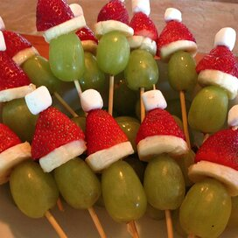

**Grinch Kabobs**

**Ingredients:**

24 green grapes

1 large banana, cut into 24 slices, or as needed

24 hulled strawberries tips removed

24 miniature marshmallows

24 toothpicks

**Directions:**

1. Thread 1 grape, 1 banana slice, 1 strawberry (narrow end facing up), and 1 marshmallow onto 1 toothpick to resemble the Grinch’s head in his red hat. Repeat with remaining grapes, and marshmallows.

**Nutrition Facts (Per Serving)**

Calories 18 Prep: 30 minutes

Protein .2 g (% DV) Total: 30 minutes

Carbohydrates 4.4 g (1% DV) Servings: 24

Fat .1 g (% DV) Yields: 24 Grinchs

Cholesterol 0 mg

Sodium 1.6 mg (% DV)